Technical test 1 –

Problem Description: Add a 'recommended' label to the 20kg selection for all passengers (based on the design below).

Code snippet for solution:

//created a div under the second div of <div class="cards__wrapper cards__third"> using ‘’EDIT HTML” Option in ‘Elements’ to add a label "Recommended" to the luggage 20kg.

//CSS Class
<div style="margin-left:100px;
padding-top: initial;
padding-right:15px;
padding-left:15px;
margin-top: -10px;height: 10px;
">
<label id="label" style="position: inherit;
padding-top: 1px;
background-color: #aad700;
padding: 2px;
color: #092a5e;
font-size: 16px;
font-weight: bold;"></label>
</div>

JavaScript
-----------
// Taking a language from dataLayer and added innerText to label according to the language.

let value = (function lable(){
let lang = dataLayer[0].page.language
let result = (lang === 'en') ? "RECOMMENDED" :
(lang === 'nl_BE') ? "AANBEVOLEN" :
(lang === 'fr_BE') ? "RECOMMANDÉ" : "" ;
console.log(lang,result)
return result
}());
document.getElementById("label").innerHTML = value.
Before code execution:
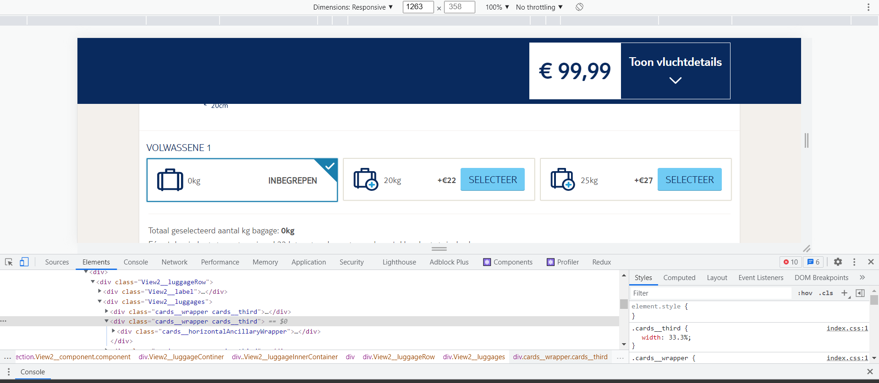

After code execution:
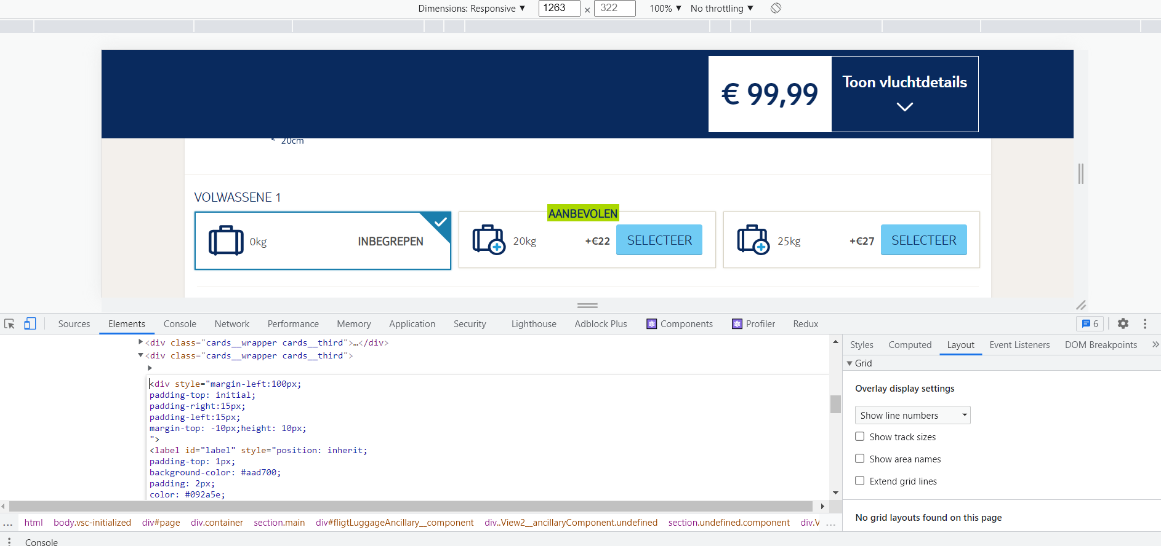

Technical test 2 –
Problem Description: Hide the discount message on search results which have a discount under the value of £200pp
Code snippet for Solution:
// To get the array of spans(array_span) using "getElementsByClassName" method.
var array_span =document.getElementsByClassName('ResultListItemV2__deposit')

//From array_span separated the text and stored it in a new array "discount_text".
var discount_text= [];
array_span.forEach((ele,i)=> {discount_text.push(ele.innerText)})

// From discount_text filtered the specific discount elements from deposit elements.
var disc_incl_text = discount_text.filter(line => line.includes("Includes"))

// Created an array of discount prices "disc_price"
var disc_price =[]
disc_incl_text.forEach(text => {disc_price.push(parseInt(text.slice(10)))})

// checked each value which is less than 200 and added CSS class to it dynamically to hide the element.
disc_price.forEach((price, i) => {
if (price< 200) {
document
.getElementsByClassName('ResultListItemV2__deposit')
[i].classList.add('hide'); //Using existing CSS class hide - to hide
}
});

Before code execution:
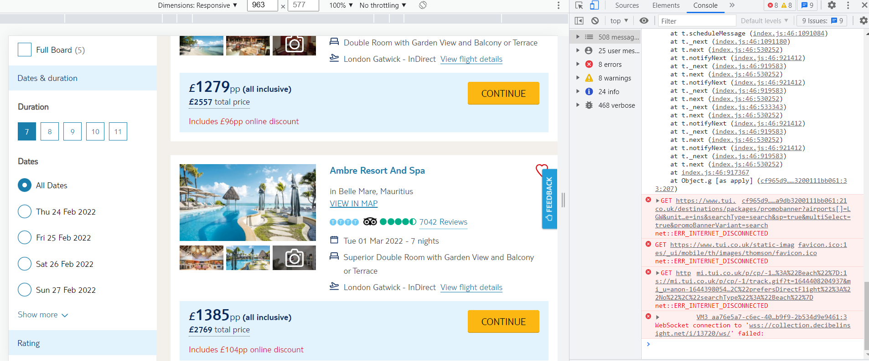
After code execution:
